Water Charging.

**Churches of Christ Housing Services may pass on the full water usage charges (including bulk water charges) to tenants, provided the required minimum criteria has been met.**

**What are the minimum criteria for water charging?**

Full water usage charges can be passed on to the tenant if:

* + the property is individually metered
  + the property is water efficient
  + the tenancy agreement states the tenant must pay for water usage.

**What water charges can be passed onto you, as the tenant?**

|  |  |
| --- | --- |
| Charge as shown on a water bill | Can this be recharged? |
| State Bulk Water Charge | Yes |
| Water Usage Charges | Yes |
| Sewerage Usage Charge | No – sewerage is not a service charge and cannot be passed on to the tenant. |
| Fixed Access Charges | No – Churches of Christ Housing Services must pay for all fixed charges for water supply. |

**What are water efficient properties?**

Properties are considered water efficient if certain water fixtures meet the required standards listed below.

|  |  |
| --- | --- |
| Water efficient devices | Minimum water efficient standard required |
| Internal cold water taps and single mixer taps (excluding bathtub taps and taps for appliances) | A maximum flow rate of nine litres per minute. |
| Showerheads | A maximum flow rate of nine litres per minute. |
| Toilets | A dual flush function not exceeding 6.5 litres on full flush and 3.5 litres on half flush and a maximum average flush volume of four litres (based on the average of one full flush and four half flushes). |

The requirement for taps applies only to internal cold water taps that are installed over a hand basin, kitchen sink or laundry trough (including single mixer taps). The requirement does not apply to other taps in the premises such as bath tub taps, outside taps for the garden, or taps which supply washing machines or dishwashers. These taps are not required to be water efficient.

At the start of your tenancy, the presence of water efficient devices installed within your home will be recorded on your Residential Tenancies Authority (RTA) Entry Condition Report.

**Can I still be charged for water if my property is not water efficient?**

Yes, however the full water usage charge will not be passed on to you. In properties managed by Churches of Christ Housing Services where water efficient devices may not be installed (e.g. older homes, properties with third party owners), we will be required to pay for a ‘reasonable’ amount of water usage. This amount will be included in the tenancy agreement and agreed upon at the start of the tenancy. Tenants will be responsible for paying for excess water usage above the agreed reasonable amount.

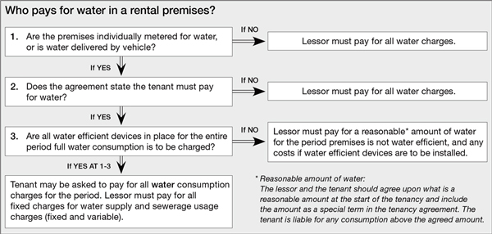

**How often will I be charged for water usage?**

Invoices for water usage will be issued to tenants in line with the local water authority billing cycle. This may differ between regions due to different local water authorities supplying water to those areas.

|  |  |
| --- | --- |
| Water Supply Authority | Region |
| Unitywater | Sunshine Coast, Moreton Bay |
| Urban Utilities | Brisbane, Ipswich, Somerset, Lockyer Valley & Scenic Rim |
| City of Gold Coast | Gold Coast |
| Logan City Council | Logan |
| Redland City Council | Redland Shire |

Churches of Christ Housing Services will send the water bill within 4 weeks of receiving it from the relevant authority. Tenants will have **one month** from the date of the invoice to make payment.

For more information about water charging, including how to make payments, please contact your housing officer.

**How can I be waterwise?**

All tenants can contribute to safeguarding our water supply for the future by being waterwise. Help conserve our water supply and save some money by making simple changes to how you use water. Further advice and information on how to be waterwise is available in your **Tenant Handbook**.