Constitution
Example Church of Christ

Version 4.5.1 as at 17/11/2023

This document is a template that you can use or work through to create your own constitution. Please review each clause and make decisions that suit your context. Particularly, the parts in [square brackets] require discussion as they contain information for you to determine e.g. age of members, or for your review e.g. faith statement. Delete the square brackets when you have reviewed the clause.

If you are making a significant change or addition, or have any questions, please contact Church Support and they will put you in touch with the best person to advise or assist. Church Support can also supply your logo for the header if you do not have it handy.
Governing Group members are often Elders and the Governing Group is the Eldership, but not in every church. The Term Governing Group can be replaced with Elders or whatever other title your church uses. Whilst you may choose to have Deacon roles within the church, we do not recommend that this group have a collective decision-making authority or governance role and therefore Deacons are not referred to in this Constitution template.

Contents
Contents 3
1. Definitions 4
2. Church Identity 4
3. Purpose 4
4. Membership 5
5. Leadership Structures 6
The Governing Group 6
Ministry Staff 8
6. Members’ Meetings 9
Conduct of Members Meetings 10
7. Indemnity 10
8. Contract Arrangements & Financial Management 10
9. Dissolution 11
10. Altering the Constitution 11

Definitions

  - Governing Group The elected leaders of the church who take ultimate responsibility for the spiritual leadership, relational health and governance requirements of the church. The Governing Group Members shall have the qualities of Elders and Deacons as defined by: 1 Timothy 3:1-13, Titus 1:6-9, and Acts 6:3-7.

  - Pastor The person elected to lead the ministry work of the church [or termed the Senior Pastor in larger staff teams] and who oversees the church staff (paid and unpaid).

Church Identity

  - The name of the church is Example Church of Christ ("the church").
  - This church shall be an affiliated member of Churches of Christ in Queensland, an incorporated body under Letters Patent, or its successors and will fulfil affiliation requirements set down by Churches of Christ in Queensland.
  - The church is an Unincorporated Association.
  - The church is established to be, and continue as a charity.

Purpose

  - The church exists for charitable purposes including, but not limited to, the advancement of religion. Specific activities of the church are to serve this purpose.

  - This church exists to fulfil the purposes for which Jesus established the Church:
[(insert your purpose or mission statement here, following is an example)
- Introducing – facilitating people’s coming to faith in Christ (Mark 16:15)
- Maturing – supporting and encouraging believers in their discipleship (Colossians 1:28)
- Caring – expressing Christ’s care and compassion to those in need (1 John 3:18)
- Worshipping – glorifying God through our lives and corporate worship expression (John 4:24)]

  - [(All of section 3.3 is optional:)

The church seeks to fulfil its purpose within the following framework of belief and practice.

The church generally supports the beliefs and practices as expressed by Churches of Christ in Australia.

AND/OR
The church has a Statement of Faith document which is adopted by the church members and can be altered by two thirds majority vote of the church members.
OR
The church holds to the following affirmations:
- the inspiration of the Old and New Testaments
- the revelation of one God in three persons: Father, Son and the Holy Spirit
- the incarnation of God in the person of Jesus Christ
- Jesus’ life and teaching as a perfect example of divine character
- the death of Jesus as a perfect sin offering for redemption and forgiveness
- the bodily resurrection of Jesus
- Jesus’ supreme authority as Lord over all
- the person and work of the Holy Spirit
- the need of salvation and the forgiveness of sins
- the invitation and requirement of faith and repentance for salvation
- the practices of baptism and communion
- the acceptance that the Church is a divine institution]

Membership

  - Membership shall be comprised of those who align with and who are committed to the life and ministry of this church. They shall be persons who repent and confess their faith in the Lord Jesus Christ as the Son of God and their personal saviour, and who seek to be obedient to Him. (Rom 10:9-10)

  - Church members agree to:
    - [Be an active participant in church life and use their gifts to serve others.
    - Support the vision and direction of the church, and the church leadership.
    - Build healthy and respectful relationships throughout the church family.
    - Prayerfully consider their financial partnership with the Church.
    - Pray about church direction and participate in Church Members’ meetings where possible. (Rom 12:4-5, Eph 4:25, Col 3:15, 1Pet 4:10)]
  - All applicants for membership will complete a membership application form and submit to the Governing Group for consideration. The approval of the Governing Group will represent the approval of the church.
  - Members must be [18] years of age, and have attended the church regularly for [6] months.
  - The Governing Group will ensure a register will be kept with the names of the members of the church. A person becomes a member when their name is entered onto the register. A person must be removed from the register as soon as possible after they cease to be a member.
  - A member may be placed under discipline by the Governing Group and lose membership privileges for a period of time. This will follow principles of natural justice and follow processes set out in the Church Conflict Resolution document. (Matthew 18:15-16)
  - Staff and Governing Group members must be members of the church.
  - The Governing Group may review the membership register and remove members who have: joined another church, requested removal from the membership register, become inactive or died.

Leadership Structures

The Governing Group
  - The purpose of the Governing Group is to:
- Oversee the spiritual and administrative affairs of the church on behalf of the Church Members, taking responsibility for the governance requirements of the church.
- Discern the specific direction of the church and provide leadership to the church with the Senior Pastor who leads the Church Staff.
- Provide accountability and support to the Pastor and through the Pastor to the broader pastoral team.

  - There will be a minimum of 3 members of the Governing Group.
  - Elections of Governing Group members occur at a Members' meeting.
  - Those elected to the Governing Group must not hold a Church Staff position.
  - Elected members may serve a maximum of [three two-year terms] before stepping down for a minimum of [two] years before being nominated for election again.
  - The Pastor will be a member of the Governing Group while they hold that position.

  - The Governing Group will appoint its own chairperson and nominate a Treasurer of the church who will take responsibility for the treasury function of the church. The treasurer may or may not be a member of the Governing Group.

  - As far as possible, consensus will be the basis of decision making by the Governing Group. Where a vote is necessary, each member has one vote. Otherwise, in other matters, the Governing Group may only act by a vote with no more than two dissents.

  - Minutes of Governing Group meetings will be kept.

  - The elected members of the Governing Group are appointed by a [majority] vote at the AGM. The Governing Group may appoint a person to fill a vacancy until the next AGM.

  - Nominations for Governing Group can be made to the Governing Group (or a Nominations Committee which consists of the Chair of the Governing Group, the Pastor and one other person appointed by the Governing Group). The Nominations Committee will then consider the applications and bring recommendations to the Church Members for appointment. Governing Group members seeking re-appointment will go through the nomination process for each term and require a [two-thirds majority] vote.

  - To be eligible for appointment as a Governing Group member, a person:

- should display a strong commitment to the life and ministry of the church and demonstrate the qualities of Christian leadership as outlined in scripture: 1 Timothy 3:1-13, Titus 1:6-9, and Acts 6:3-7;
- must not be ineligible to be a responsible person under the ACNC legislation;
- must hold a current blue card;
- must not be a spouse or immediate family member of a member of the Governing Group, or member of staff;
- must be a Member of the church at the time of their nomination, election and for the duration of their time on the Governing Group.

  - A person will cease to be a member of the Governing Group if they:

- are no longer eligible under clause 5.12
- resign, by writing to the Governing Group having immediate effect or with effect from a specified date in the notice;
- retire under clause 5.5;
- stop being a Member of the Church;
- are removed by a resolution of Members of the Church;
- are absent without the consent of the Leadership Team from all meetings of the Team held during a period of six months; or
- die.

  - The Governing Group will meet as agreed to by the Group. A meeting may be called for any purpose and at any time or place by resolution of [three] Group members. The Governing Group will meet at least [4] times per year.

  - The quorum for meetings of the Governing Group will be half the group plus one and meetings will usually be held face-to-face. However, the linking together of members using telephone or other electronic audio-visual communication shall constitute attendance at a meeting. In this instance the member/s must be able to receive the input of the other members taking part in the meeting, and acknowledge their presence for the purpose of the meeting at its commencement.

Ministry Staff

  - The staffing structure for the church (paid and unpaid) shall be determined by the Governing Group and shall be communicated to the church. The Governing Group shall ensure that the roles and responsibilities are documented for each position established.

  - The Governing Group will identify and recommend nominees for Pastoral staff to the Members for voting.
  - (optional) The appointment and termination of all other staff will be managed by the Pastor, in consultation with Governing Group.
  - Pastoral appointments are moved for acceptance at a Members’ Meeting and require a [two-thirds majority] vote to be considered for employment. Any fixed term pastoral appointment must not exceed 2 years (including any extension or renewal period). Votes for pastoral appointments will be held by secret ballot.

  - The Governing Group may terminate a staff member’s contract in the following instances:
- as a result of a performance management process
- due to a matter of moral offence or misconduct
In either of the above cases, the Governing Group will act in accordance with the CofCQ Ministers Appointment and Employment Guide and Fair Work Queensland.

Members’ Meetings
  - The Governing Group shall arrange at least one Members’ Meeting per year, one of which shall be the Annual General Meeting. All agenda items for Members’ Meetings are approved by the Governing Group prior to the meeting.

  - The date, time, place, and proposed motions for all such meetings shall be advised to the church at least two weeks before the meeting is held.

  - If at least [33%] of the Members on the membership register give written notice to the Governing Group that they want a matter brought to the notice of the Members, then:
  - The Governing Group will call a forum to discuss the matter raised and if possible resolve it without having to call a Members’ Meeting; and
  - If the matter cannot be resolved the Governing Group will call a Members’ Meeting to resolve the matter.
  - The AGM will be held within six months of the end of the financial year.

  - The agenda of the AGM will include the presentation and receipt of the reviewed annual church accounts and election of Governing Group Members.

Conduct of Members Meetings
  - The Governing Group shall appoint a chair for the members’ meetings.

  - A quorum will be [1/3] of the members [either in person or votes having been received]. If the quorum is not achieved at a meeting, a subsequent meeting with the same agenda can be arranged within two weeks of the original meeting, with the notice requirements having been already fulfilled.

  - Proxy voting [shall] be allowed.

  - Motions shall be declared passed by a simple majority unless otherwise stated in the constitution.

  - Scrutineers shall be appointed to manage all ballots.

  - A record of the meeting will be kept and the major decisions and any key matters shall be reported to the church within a month of the meeting being held.

Indemnity
  - To the extent possible under law, members (including Governing Group Members and Staff) are entitled to be indemnified out of the assets held for the church for any debts or liabilities incurred personally by a member when acting on behalf of the church, so long as the member was:
- authorised by the church to take that action, and
- acting in good faith (fairly and honestly and in the best interests of the church).
  - This indemnity is a continuing obligation and is enforceable by a person even if that person is no longer a member of the church. This indemnity only applies to the extent that the person is not otherwise entitled to be indemnified and is not actually indemnified by another person (including an insurer under an insurance policy).

Contract Arrangements & Financial Management
  - The Governing Group is entrusted with the stewardship of the resources of the church and shall ensure that they are directed to the achievement of its purposes. The Governing Group will abide by the church’s Financial Practices Guidelines.

  - The Governing Group shall be responsible for the preparation of an annual budget, which is presented to the church at the annual members meeting.
  - The financial records shall be reviewed annually by a qualified, independent party, with the financial reports provided at an annual meeting and kept for the required period of time to meet external affiliation requirements.

  - The financial year of the Church runs from [1 July to 30 June].

  - As an unincorporated association, where the Church cannot enter into contracts in its own name, the Governing Group may appoint three or more individuals to be signatories to these contracts. CofCQ may, at times, fill this role where appropriate.

  - The assets and income of the Church shall be applied solely to further its objects and no portion shall be distributed directly or indirectly to the members of the Church except as genuine compensation for services rendered or expenses incurred on behalf of the Church.

Dissolution
  - Should the church either permanently close, or cease to be an affiliated member of the Churches of Christ in Queensland, all funds, assets, property and equipment that remain after the satisfaction of all liabilities, shall become the property of Churches of Christ in Queensland or another entity being an entity with the purpose of the advancement of religion and endorsement by the commissioner of taxation as a tax concession charity, in consultation with Churches of Christ in Queensland.
  - Any surplus assets must not be distributed to a member or a former member of the church.

Altering the Constitution
  - Amendments to this constitution can only be made by a [simple majority] vote of members at a church meeting. This constitution shall be changed to meet any requirements of the Churches of Christ in Queensland constitution adopted by affiliated member churches.

  - Where this document is interpreted to be at odds with the constitution of the Churches of Christ in Queensland, then the constitution of Churches of Christ in Queensland shall take precedence.

  - The members must not pass a resolution that amends these rules if passing it causes the church to no longer be a charity.

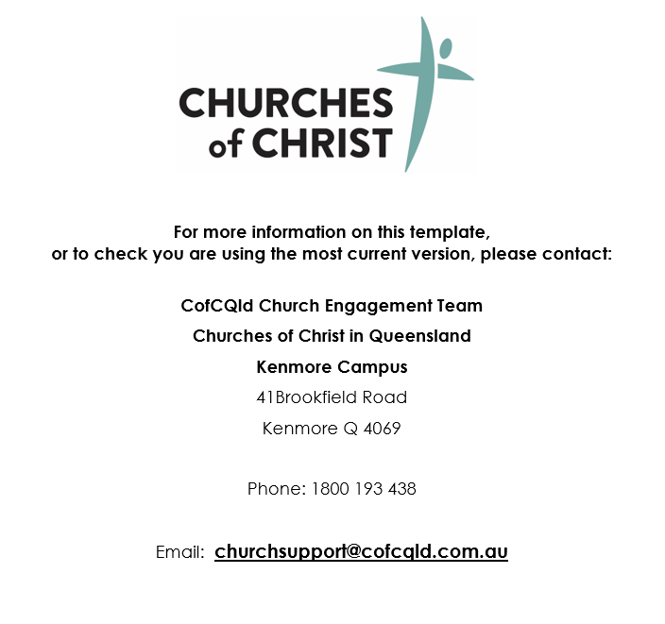
Delete the box above before finalising your constitution

