Pest Management.

**Pests and rodents can carry organisms and bacteria that cause human diseases, including food poisoning, dysentery and diarrhoea. They can also cause allergic reactions in some people when dried faecal particles(poo) mix with house dust. The sight of pests and rodents can also cause considerable psychological or emotional distress for some people.**

Pests and rodents also cause significant damage to your home, particularly to costly items such as electrical wiring and ceiling insulation – not to mention the damage to your appliances and furniture.

## What are my responsibilities as a tenant?

As a tenant, you have a duty to keep your home free of pests and rodents. This also benefits you by reducing the health risks associated with infestations. If your living conditions contribute to the harbouring of pests and rodents, you may be recharged the cost of a pest control treatment, as well as any repairs required.

You can arrange for a qualified pest control company to treat your home at your own expense. You do not need our approval for this. If you live in a multi-unit complex, you may wish to contact the other tenants for their agreement to have everyone treat their units at the same time. This approach may achieve a cheaper price for each unit.

## Tips for keeping pests and rodents out of your home

**Remove food:**

* + Remove stray food particles lying around by wiping bench tops and vacuuming floors regularly.
  + Do not leave food scraps exposed and make sure bins are covered (with a tight lid).
  + Keep appliances clean and free of crumbs and food particles.
  + Keep food in sealed containers.
  + Do not leave pet food out overnight as it attracts cockroaches and rodents.
  + Keep bird cage trays clean, and sweep up bird seed and husks around cages, as it attracts vermin.

**Remove water:**

* + Leaking water is an open invitation for pests and standing water makes a great breeding ground for insects, so report any leaks as soon as possible.

**Remove shelter:**

* + Clutter makes a great place for bugs, mice, and other creepy crawlies to hang out. Cut the clutter. Reduce or remove old newspapers and boxes.

**Remove opportunity:**

* + If you go camping or bring new or second-hand furniture or clothing home, make sure you clean it off and even spray it with bug spray before bringing it inside. Do the same for items that have been sitting in a shed or garage before bringing it in the house.
  + Take your shoes off before entering your home.
  + Grow plants that attract beneficial insects such as garden spiders as well as birds; they make great all-natural pesticides.
  + Regularly treat pets with flea control products.
  + Regularly vacuum mattresses and wash pillows and bed linen in warm water (following care instructions).

## Cockroaches

Cockroaches are night-time creatures rarely seen in any quantity during daylight hours. However, in areas where there are heavy infestations, sightings of cockroaches will become more common. It is generally accepted that for every cockroach seen there are at least a further ten that are hidden away in out of sight places. Common nesting areas include cracks and crevices, dishwashers, electrical motors (such as in fridges and freezers), switches, toasters, ovens and almost any warm, moist area where food is available. Infestation occurs when cockroaches are carried into your home in furniture or packaging or gain entry to the premises through drain covers, ventilation openings and under doors.

**Common types of cockroaches and signs of infestation:**

Cockroaches are productive breeders with the most common being the German cockroach, capable of producing 20,000 offspring within a twelve-month period.

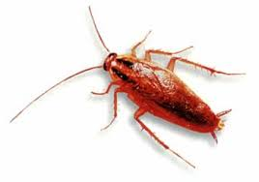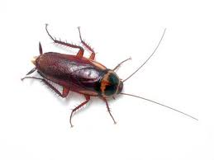

German Cockroach

Approx. 12-16mm in length.

Pale brown to black in colour with two parallel lines along the length of its back.

Australian Cockroach

Approx. 30-35mm in length.

Yellow border behind the head

Dark Reddish brown in colour.

Light markings on thorax.

Tell-tale signs indicating cockroach activity include the presence of egg cases, regurgitation marks (black/brown spots), faecal pellets, odour and cast-off skins.

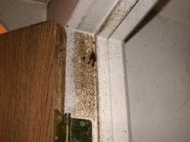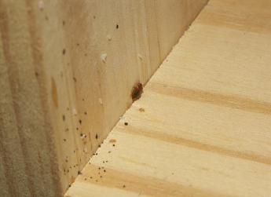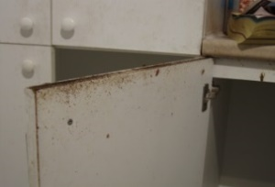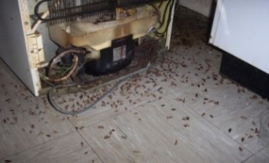

## Rodents

One female mouse can produce as many as 10 litters in one year. Furthermore, young are born within 20 days after mating and are capable of reproduction within two months. The normal life span of a mouse is between nine months and one year. As such, mouse infestations grow rapidly and prove extremely difficult to exterminate.

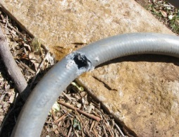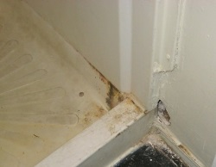

Unless an infestation is severe, you may never physically see a mouse or rat. Some signs of rodent infestation may include:

* + rodent droppings around food packages, in drawers or cupboards, and/or under the sink.
  + nesting material such as shredded paper, fabric, or dried plant matter.
  + evidence of gnawing and chewing on food packaging or structures.
  + evidence of damaged structures providing entry points into the home.
  + stale smells coming from hidden areas.

## Bed Bugs

Adult bed bugs are wingless insects, oval in shape, 5-6mm long when fully grown, and are fast runners. They are rust brown in colour and change to a deeper red brown following a blood meal. The juvenile stages, called nymphs, tend to be paler in colour and are 1-4mm in length. Bed bugs are dorsoventrally flattened and being thin means that they can hide in narrow cracks and crevices, making detection often very difficult.

Being a secretive species, bed bugs tend to shelter in dark locations, mostly close to where people sleep. This includes under mattresses, floorboards, paintings and carpets, behind skirting, in various cracks and crevices of walls, within bed frames and other furniture, and behind loose wallpaper. Bed bugs tend to stay in close contact with each other and heavy infestations are accompanied by a distinctive sweet ‘buggy’ smell. Blood spotting on mattresses and nearby furnishings is often a tell-tale sign of an infestation.

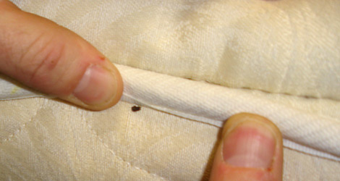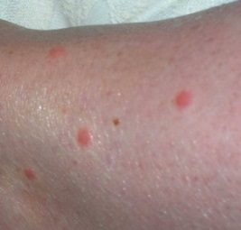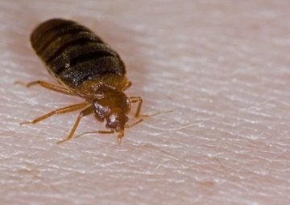

## Fleas

Fleas are a type of wingless parasite found worldwide. They feed off the blood of humans and animals such as dogs and cats. Since fleas use a wide range of hosts, diseases can be transferred from one host to another. There are three main species of flea that infest humans:

* + Cat flea (Ctenocephalides felis)
  + Dog flea (Ctenocephalides canis)
  + Human flea (Pulex irritans)

The cat and dog flea are common in Australia. A flea bite is intensely itchy and secondary infections caused by scratching are common. Dogs and cats are common ‘reservoirs’ for fleas. Your pet may be irritated by flea bites and scratch often. Check for fleas by parting the fur, particularly around the ears and rump. Look for the fleas themselves or for flea faeces (poo). Flea faeces look like miniscule dark specks.

## Where to get help and advice

Depending on your concern, you can get extra advice and assistance from any of the following:

* + 13 HEALTH – for confidential expert health information and advice (24 hours - 7 days)
  + Licensed pest control operators – we can supply you with qualified business details
  + Your doctor
  + Your local councilA black background with a black square

    Description automatically generated with medium confidence